TITLE OF THE PAPER

First A. Author¹, Second B. Author^{1,2} and Third C. Author²

¹ Authors’ Department, Institute, COUNTRY.
² Author’s Department, Institute, COUNTRY.

(E-mail: firstauthor@aaaa.bbb, secondauthor@aaaa.bbb, thirdauthor@aaaa.bbb)

ABSTRACT

Please provide a brief and clear description of the work to be presented, including essential information such as: background, aim and scope of the work; adopted methods and techniques; elements of novelty; main achievements and conclusions. Do not include figures, tables, equations or references in the abstract!
IMPORTANT: Please include the 3-digit identifier of your paper into the header of this page (top right position). The 3-digit identifier is your abstract ID, e.g. 005 or 103. You will find this in your notification email.

KEYWORDS:
List of at most six keywords arranged in alphabetical order.

INTRODUCTION

The paper starts here with two blank lines before first section title. Introduce the topic of your work in this section.

Use one blank line before and after each subsequent section’s title. Section titles are 11 point font, must be all uppercase and text aligned left, and must be numbered in Arabic numerals as shown above.

Please use automatic hyphenation, be sure that there is continuity within your paragraphs and check the spelling. Choose a single-spaced, one-column format, on paper 21 x 29.7 centimeters. Set all margins to 2.54 centimeters.

Do not indent the first line of a paragraph; rather add one blank line between paragraphs. Use Calibri font and font size 11 for the main body of the paper.

Use references/footnotes, when necessary, in Calibri font size 10.

Do not automatically number your pages, since we will need to consecutively number the proceedings.

Note that it is the Author’s responsibility to review the final PDF version of the paper to ensure proper translation into PDF. Be sure that the contents, figures and any number, text or symbol can be translated into PDF. Final PDF file size should not be larger than 4 MB. Papers should be between 4 and 14 pages.

CHAPTER

Subchapter
The first letter of each important word of the subsection title is capitalized.

Equations should be centered and sequentially numbered. Use Calibri font with a font size 11 for the text variables and corresponding sizes proportionally for the subscripts and superscripts.

$$A=B+\int_{0}^{∞}{Cdt}$$ | (1)

All paragraphs, section or subsection headings, as well as equations are separated by just one single empty line.

Figures and tables should appear as closely as possible to where they are first cited in the text. Figures are numbered in Arabic numerals, with the caption centered below the figure, in boldface. Use two blank lines before the figure and after the figure caption.

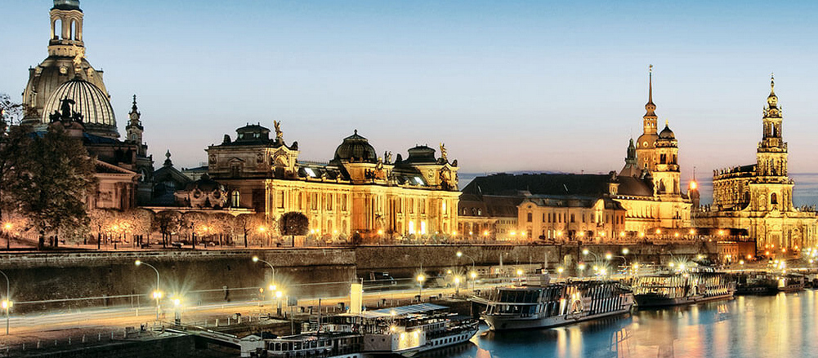
Figure 1. Text.

CONCLUSIONS

Present your summary and conclusions here.

NOMENCLATURE (IF NEEDED)

If variables are extensively used in the text, a Nomenclature section would be helpful to the readers.

ACKNOWLEDGEMENTS

Acknowledge the help of colleagues, sources of funding, etc.

REFERENCES

- The Nuclear Engineering Textbook, eds. A. Editor, and C. Editor, Publisher, 2011.
- A. Author, B. Author and C. Author, "Paper title," Applied Technology Journal, vol. 15, pp. 111-121, 2010.
- A. Authors and B. Author, "Proceedings paper title," Proceedings of the 20th International Conference on Nuclear Engineering, pp. 111-121, 2012.

APPENDIX A

If necessary, include Appendices numbered in upper case alphabetical order.

